Case Study No: 2
Experiment Title: To perform Data different data types (string, number, Boolean, etc.) and display them.

Case Study Title: Develop the webpage for an online shopping website with using HTML, CSS and HTML5 tags.
And calculate the bill.

Software/ Tools Required: VS Code (text editor), HTML, CSS, JavaScript.

Case Study Program Code:
Index.html –
<!DOCTYPE html>
<html lang="en">
<head>
<meta charset="UTF-8">
<meta name="viewport" content="width=device-width, initial-scale=1.0">
<title>Online Shopping Store</title>
<link rel="stylesheet" href="style.css">
</head>

<body>

<header>
<h1>🛒 Online Shopping Store</h1>
<p>Buy Your Favorite Electronics</p>
</header>

<section class="products">

<div class="card">
<h2><span>💻</span><br>Laptop</h2>
<p class="price">₹25000</p>

<label>Quantity</label><br>
<input type="number" id="laptop" value="0" min="0"><br>

<button onclick="addItem('Laptop',25000,document.getElementById('laptop').value)">
Add to Cart
</button>
</div>

<div class="card">
<h2><span>📱</span><br>Mobile</h2>
<p class="price">₹15000</p>

<label>Quantity</label><br>
<input type="number" id="mobile" value="0" min="0"><br>

<button onclick="addItem('Mobile',15000,document.getElementById('mobile').value)">
Add to Cart
</button>
</div>

<div class="card">
<h2><span>🎧</span><br>Headphones</h2>
<p class="price">₹2000</p>

<label>Quantity</label><br>
<input type="number" id="headphone" value="0" min="0"><br>

<button onclick="addItem('Headphones',2000,document.getElementById('headphone').value)">
Add to Cart
</button>
</div>

<div class="card">
<h2><span>⌨️</span><br>Keyboard</h2>
<p class="price">₹1200</p>

<label>Quantity</label><br>
<input type="number" id="keyboard" value="0" min="0"><br>

<button onclick="addItem('Keyboard',1200,document.getElementById('keyboard').value)">
Add to Cart
</button>
</div>

<div class="card">
<h2><span>🖱️</span><br>Mouse</h2>
<p class="price">₹800</p>

<label>Quantity</label><br>
<input type="number" id="mouse" value="0" min="0"><br>

<button onclick="addItem('Mouse',800,document.getElementById('mouse').value)">
Add to Cart
</button>
</div>

</section>

<section class="bill">

<h2>🧾 Bill Receipt</h2>
<div id="receipt">
Your cart is empty.
</div>

<button class="billBtn" onclick="generateBill()">
Generate Bill
</button>

</section>

<footer>
Created by: Ritisha Naigaonkar-045, A2 Batch
</footer>

<script src="script.js"></script>

</body>
</html>

Script.js –
var cart = [];

function addItem(name, price, qty)
{
qty = parseInt(qty);

if (isNaN(qty) || qty <= 0)
{
alert("Please enter a valid quantity for " + name + ".");
return;
}

var found = false;

for (var i = 0; i < cart.length; i++)
{
if (cart[i].name == name)
{
cart[i].qty += qty;
found = true;
break;
}
}

if (!found)
{
cart.push({
name: name,
price: price,
qty: qty
});
}

alert(name + " added to cart!");
}

function generateBill()
{
if (cart.length == 0)
{
document.getElementById("receipt").innerHTML =
"<b>Your cart is empty.</b>";
return;
}

var bill = "";
var subtotal = 0;

for (var i = 0; i < cart.length; i++)
{
var amount = cart[i].price * cart[i].qty;
subtotal += amount;

bill +=
"<b>" + cart[i].name + "</b><br>" +
"Price : ₹" + cart[i].price + "<br>" +
"Quantity : " + cart[i].qty + "<br>" +
"Amount : ₹" + amount + "<hr>";
}

var discount = 0;

if (subtotal > 5000)
{
discount = subtotal * 0.10;
}

var total = subtotal - discount;

bill +=
"<h3>Subtotal : ₹" + subtotal + "</h3>" +
"<h3>Discount : ₹" + discount + "</h3>" +
"<h2>Total Bill : ₹" + total + "</h2>";

document.getElementById("receipt").innerHTML = bill;
}

Style.css –
*{
margin:0;
padding:0;
box-sizing:border-box;
font-family:Arial, Helvetica, sans-serif;
}

body{
background:linear-gradient(135deg, lavender, beige);
background-attachment:fixed;
}

header{
background:mediumslateblue;
color:white;
text-align:center;
padding:25px;
box-shadow:0 5px 12px gray;
}

header h1{
margin-bottom:8px;
}

.products{
display:flex;
flex-wrap:wrap;
justify-content:center;
gap:25px;
padding:35px;
}

.card{
width:220px;
background:white;
border-radius:18px;
padding:20px;
text-align:center;
box-shadow:0 8px 20px silver;
animation:float 4s ease-in-out infinite;
transition:0.4s;
}

.card:hover{
transform:translateY(-12px) scale(1.05);
box-shadow:0 15px 30px gray;
}

.card span{
font-size:45px;
}
.card h2{
margin-bottom:10px;
color:indigo;
}

.price{
font-size:20px;
color:mediumslateblue;
font-weight:bold;
margin-bottom:15px;
}

.card label{
font-weight:bold;
}

.card input{
width:70px;
padding:8px;
margin:12px 0;
text-align:center;
border:1px solid gray;
border-radius:8px;
}

button{
background:mediumslateblue;
color:white;
border:none;
padding:10px 18px;
border-radius:25px;
cursor:pointer;
font-weight:bold;
transition:0.3s;
}

button:hover{
background:indigo;
transform:scale(1.08);
}

.bill{
width:450px;
margin:20px auto;
background:white;
padding:25px;
border-radius:18px;
box-shadow:0 8px 20px silver;
}

.bill h2{
text-align:center;
color:indigo;
margin-bottom:15px;
}

#receipt{
line-height:28px;
min-height:100px;
margin-bottom:20px;
}

.billBtn{
width:100%;
font-size:16px;
}

footer{
background:black;
color:white;
text-align:center;
padding:15px;
margin-top:35px;
}

@keyframes float{

0%{
transform:translateY(0);
}

50%{
transform:translateY(-8px);
}

100%{
transform:translateY(0);
}
}

@media(max-width:600px){

.products{
flex-direction:column;
align-items:center;
}

.bill{
width:90%;
}
}
Output:
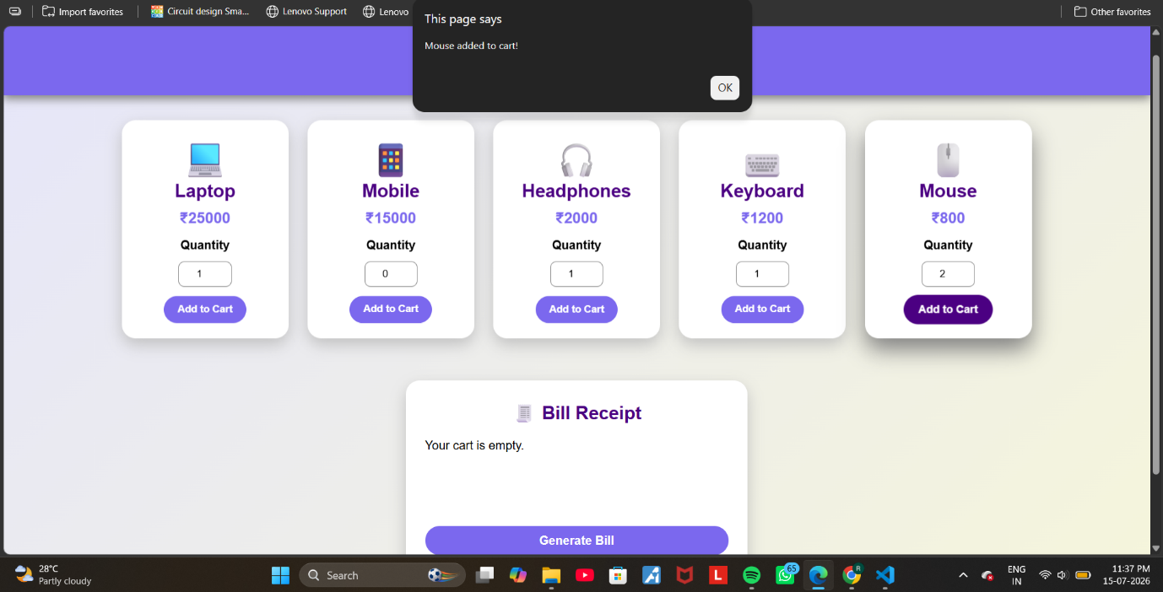

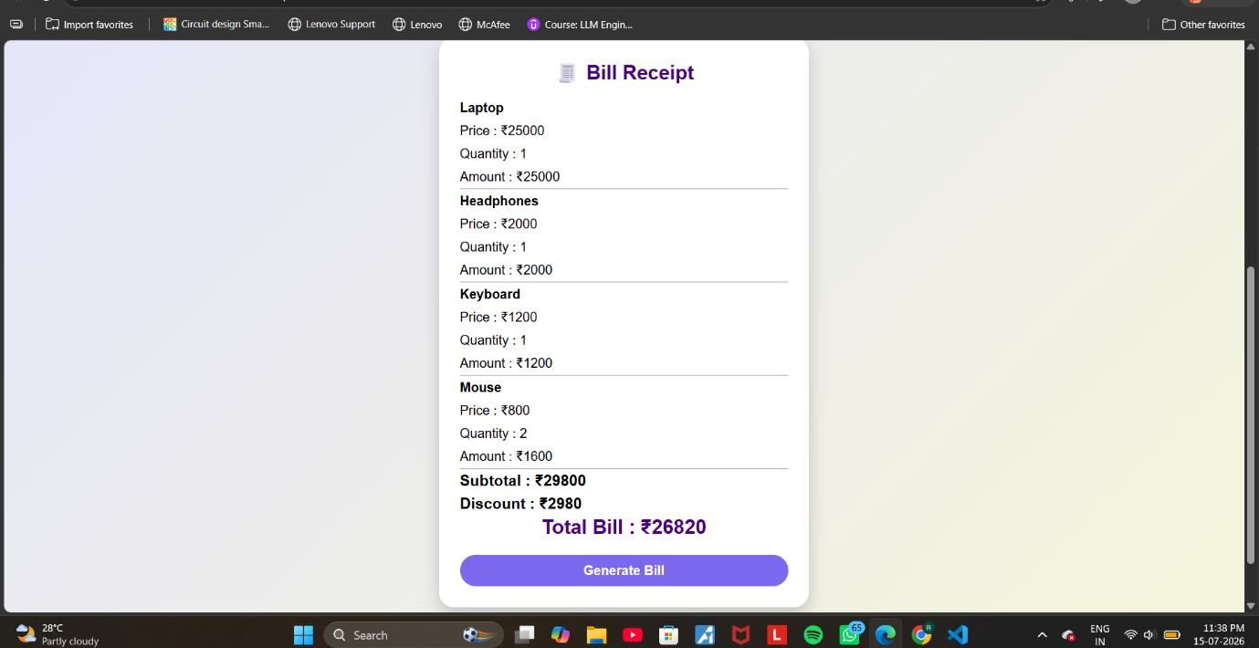

Result/ Conclusion: Thus a working website has been created using HTML, JS and its UI was styled using CSS.

Ritisha Naigaonkar, Sem5-A, 24070521045

